

Capstone Project Report
Report 3 – Software Requirement Specification

– Hanoi, August 2019 –
Table of Contents
I. Record of Changes 3
II. Software Requirement Specification 4
1. Product Overview 4
2. User Requirements 6
2.1 Actors 6
2.2 Use Cases 6
3. Functional Requirements 15
3.1 System Functional Overview 15
3.2 Detailed Function Design 23
4. Non-Functional Requirements 27
4.1 External Interfaces 27
4.2 Quality Attributes 27
5. Requirement Appendix 29
5.1 Business Rules 29
5.2 Common Requirements 31
5.3 Application Messages List 31

I. Record of Changes
Date | A*  M, D | In charge | Change Description
27/08/2026 | A | Hà Đông Hải | Software Requirement Specification for the complete platform: 5 client surfaces, 109 use cases, 75 distinct screens and 68 entities.
*A - Added M - Modified D - Deleted

II. Software Requirement Specification

1. Product Overview
MusicLounge is a ticketing, livestream and donation platform built for small live-music venues in Vietnam. It replaces the patchwork of paper door sales, general-purpose ticketing, ungated streaming and informal cash tipping that such venues rely on today with a single system built around how they actually operate: a ticket valid for the whole evening, walk-in sales that continue after the music starts, a livestream limited to genuine ticket holders, and an auditable path from an audience member's tip to the performer who earned it.
The platform is delivered as 5 client applications over one shared REST and SignalR API, each built for one job rather than one universal app: the Audience Website (discover, buy, watch, tip, rate), the Audience Mobile app (order food and drink while seated at a venue), the Owner Web Dashboard (venue setup, shows, money), the Staff Mobile app (counter sales, door check-in, the F&B board) and the Admin Web Console (approval, moderation, refunds, complaints, monitoring).
Figure 1 shows the system boundary: who exchanges data with the platform, and in which direction. Everything inside the boundary is built by this project; everything outside is a third-party service the platform integrates with.
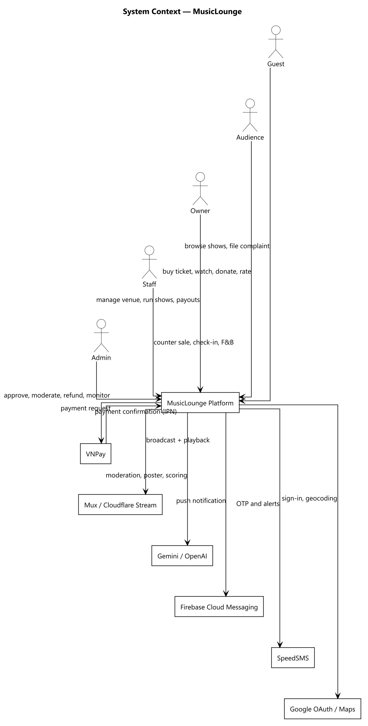
Figure 1 — System context — actors and external services around the platform boundary
Constraints and assumptions. All payments are intermediated by a licensed gateway and the platform never handles card data. The user interface is Vietnamese-only, because the platform targets the Vietnamese market. Door check-in and counter sales assume connectivity — there is no offline mode, deliberately, to avoid double-selling a seat. Administrator accounts are provisioned directly by an operator; there is no self-service path to become one.

2. User Requirements

2.1 Actors
The platform has 6 actors. Four of them (4) hold accounts and sign in; Guest is the unauthenticated visitor, and Performer is a catalogue record maintained by an Owner rather than a login of its own.
# | Actor | Description
1 | Guest | An unauthenticated visitor. Can browse published shows and venues, explore a 360° tour, and file a complaint with a reference number — but cannot buy, watch or donate.
2 | Audience | A registered customer. Discovers shows, buys and manages tickets, watches gated livestreams, tips performers, orders food and drink in-venue, rates shows and files complaints.
3 | Owner | Runs one or more venues. Registers the venue, manages seating zones and the 360° tour, creates and operates shows, handles donations and views earnings. Pays a platform subscription.
4 | Staff | Assigned by an Owner to exactly one venue. Sells walk-in tickets at the counter, checks tickets at the door, works the F&B order board and starts or ends a broadcast.
5 | Admin | Platform operator. Approves venues, moderates shows and livestreams, processes refunds, verifies bank accounts, issues penalties, resolves complaints and monitors the ledger. Provisioned directly in the database — there is deliberately no self-service path.
6 | Performer | Appears in a show's line-up and receives donations. Has a public profile and a payout bank account but no login of its own — an Owner maintains the record on their behalf.

2.2 Use Cases
109 use cases across 11 feature areas. Each is named as a verb phrase from the actor's point of view and describes an interaction that leaves the actor with something of value.

2.2.1 Diagram(s)
The use cases are split across two diagrams to stay legible: the public and customer-facing side, then the operator side. An actor generalisation arrow means the child actor can also do everything the parent can.
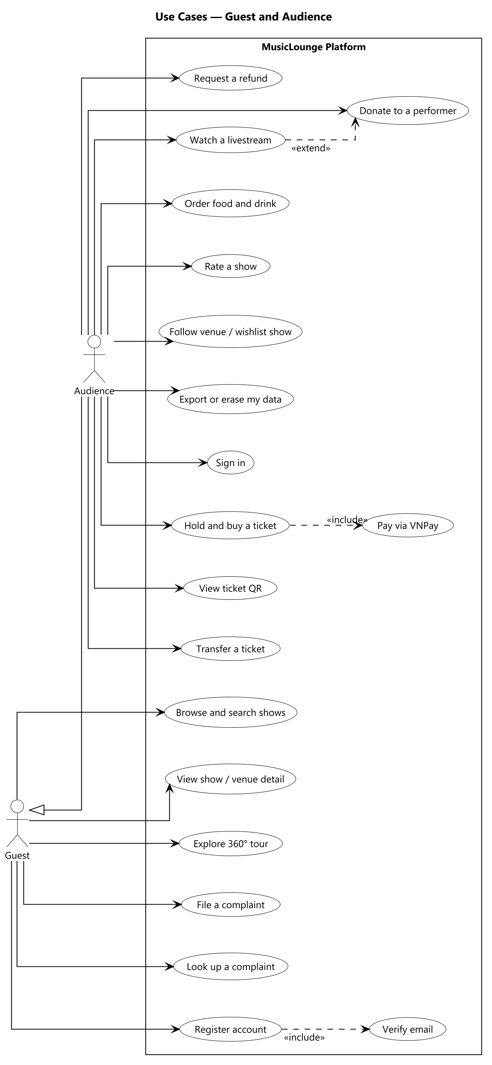
Figure 2 — Use cases — Guest and Audience
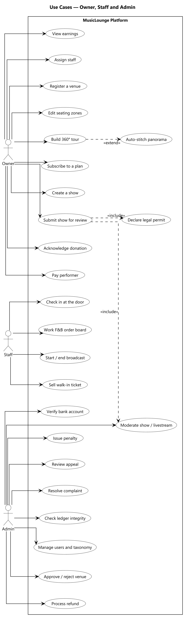
Figure 3 — Use cases — Owner, Staff and Admin

2.2.2 Descriptions
ID | Feature Area | Use Case | Actors | Description
UC-01 | Account & Identity | Register account | Guest | Create an Audience or Owner account; Staff and Admin cannot self-register.
UC-02 | Account & Identity | Verify email | Guest | Enter the emailed one-time code to activate the account and receive the first token.
UC-03 | Account & Identity | Verify phone number | Audience, Owner | Confirm a phone number by SMS code, required before certain actions.
UC-04 | Account & Identity | Sign in | Audience, Owner, Staff, Admin | Authenticate with email and password and receive a session token.
UC-05 | Account & Identity | Sign in with Google | Guest | Authenticate through Google as an alternative to a local password.
UC-06 | Account & Identity | Recover password | Guest | Request a reset link and set a new password; all existing sessions are invalidated.
UC-07 | Account & Identity | Edit profile | Audience, Owner, Staff, Admin | Update display name, contact details and avatar.
UC-08 | Account & Identity | Upload identity document | Owner | Submit identity images required before payout can be verified.
UC-09 | Account & Identity | Set AI preferences | Audience | Opt in or out of behaviour logging and personalised recommendations.
UC-10 | Account & Identity | Export my data | Audience, Owner, Staff | Download a machine-readable copy of one's own personal data.
UC-11 | Account & Identity | Erase my data | Audience, Owner, Staff | Irreversibly anonymise the account while retaining legally required financial records.
UC-12 | Account & Identity | Sign out | Audience, Owner, Staff, Admin | End the current session.
UC-13 | Discovery | Browse shows | Guest, Audience | List published shows with paging.
UC-14 | Discovery | Search and filter shows | Guest, Audience | Narrow by genre, mood, date, city or price.
UC-15 | Discovery | View show detail | Guest, Audience | See line-up, tiers, venue and availability.
UC-16 | Discovery | View venue detail | Guest, Audience | See a venue profile, gallery and upcoming shows.
UC-17 | Discovery | Explore 360° virtual tour | Guest, Audience | Navigate panorama scenes and hotspots of a venue.
UC-18 | Discovery | View performer profile | Guest, Audience | See a performer's biography, links and upcoming appearances.
UC-19 | Discovery | Follow a venue | Audience | Subscribe to a venue's updates.
UC-20 | Discovery | Add show to wishlist | Audience | Save a show for later.
UC-21 | Discovery | View personalised recommendations | Audience | See an opt-in ranked feed of suggested shows.
UC-22 | Discovery | Rate a show | Audience | Leave a star rating and comment after a show ends.
UC-23 | Ticketing | Hold tickets | Audience | Reserve a tier and quantity for a fixed countdown before payment.
UC-24 | Ticketing | Pay for a ticket | Audience | Complete payment through the gateway and receive a confirmed ticket.
UC-25 | Ticketing | Cancel a hold | Audience | Release a reservation before it expires.
UC-26 | Ticketing | View my tickets | Audience | List confirmed, used and cancelled tickets.
UC-27 | Ticketing | View ticket QR | Audience | Show the code presented at the door.
UC-28 | Ticketing | Transfer a ticket | Audience | Offer a ticket to another account; it is frozen while pending.
UC-29 | Ticketing | Accept a transferred ticket | Audience | Take ownership of a ticket offered by another account.
UC-30 | Ticketing | Cancel a ticket | Audience | Request cancellation, creating a refund request for review.
UC-31 | Ticketing | Request a refund | Audience | Ask for money back against a confirmed ticket.
UC-32 | Ticketing | Sell a walk-in ticket | Staff, Owner | Take cash at the counter and issue a confirmed ticket immediately.
UC-33 | Ticketing | Check in a ticket | Staff | Scan a code at the door and mark the ticket used.
UC-34 | Venue Management | Register a venue | Owner | Create a venue with address and business licence, pending approval.
UC-35 | Venue Management | Edit venue profile | Owner | Update description, atmosphere, contact and imagery.
UC-36 | Venue Management | Manage venue gallery | Owner | Add or remove showcase photographs.
UC-37 | Venue Management | Create seating zone | Owner | Define a named area with a real physical capacity.
UC-38 | Venue Management | Arrange seating layout | Owner | Position zones on the floor-plan image.
UC-39 | Venue Management | Upload panorama scene | Owner | Add a finished 360° image to the virtual tour.
UC-40 | Venue Management | Auto-stitch panorama | Owner | Submit several photos for the imaging service to assemble.
UC-41 | Venue Management | Place tour hotspot | Owner | Link scenes together or attach an information popup.
UC-42 | Venue Management | Define custom criteria | Owner | Add venue-specific tags used by the recommender.
UC-43 | Venue Management | Assign staff | Owner | Grant an existing account Staff access to this venue.
UC-44 | Venue Management | Deactivate staff | Owner | Revoke a staff assignment.
UC-45 | Venue Management | Register bank account | Owner | Add the payout account for venue earnings.
UC-46 | Show Management | Create a show | Owner | Draft a show with schedule, description and format.
UC-47 | Show Management | Build performer line-up | Owner | Add performers and their donation eligibility per slot.
UC-48 | Show Management | Create performer profile | Owner | Add a performer to the catalogue.
UC-49 | Show Management | Define ticket tier | Owner | Create a priced access tier with capacity.
UC-50 | Show Management | Define pricing window | Owner | Set sale start, end and channel for a tier.
UC-51 | Show Management | Generate show poster with AI | Owner | Produce a poster image within the plan quota.
UC-52 | Show Management | Upload show poster | Owner | Attach an existing image instead.
UC-53 | Show Management | Declare legal permit | Owner | Record the performance permit and royalty references.
UC-54 | Show Management | Submit show for review | Owner | Move a draft into the moderation queue.
UC-55 | Show Management | Reschedule a show | Owner | Change the date or time of a published show.
UC-56 | Show Management | Change show format | Owner | Switch between in-person and online, refunding as required.
UC-57 | Show Management | Cancel a show | Owner | Cancel and refund every confirmed ticket.
UC-58 | Livestream & Donation | Start broadcast | Owner, Staff | Open the stream for a published show.
UC-59 | Livestream & Donation | End broadcast | Owner, Staff | Close the stream normally.
UC-60 | Livestream & Donation | Watch a livestream | Audience | View a stream as a genuine ticket holder within the device limit.
UC-61 | Livestream & Donation | Send chat message | Audience | Post to the live chat, subject to rate limiting.
UC-62 | Livestream & Donation | View viewer count | Owner, Staff | See how many are currently watching.
UC-63 | Livestream & Donation | Donate to a performer | Audience | Tip a performer in the current line-up.
UC-64 | Livestream & Donation | Set donation privacy | Audience | Choose anonymity, amount visibility and message publication.
UC-65 | Livestream & Donation | View public donation ticker | Guest, Audience | See donations as they clear.
UC-66 | Livestream & Donation | View donation transparency feed | Guest, Audience | Review settled donations across the platform.
UC-67 | Livestream & Donation | Acknowledge a donation | Owner | Confirm receipt of a donation on the performer's behalf.
UC-68 | Livestream & Donation | Confirm performer payout | Owner | Record that the performer's share has been transferred, with evidence.
UC-69 | Livestream & Donation | View my donations | Audience | Track the status of tips given.
UC-70 | Livestream & Donation | Force-stop a livestream | Admin | Terminate a stream that breaches policy.
UC-71 | Food & Beverage | Manage F&B menu | Owner | Create menus and items with prices.
UC-72 | Food & Beverage | Browse menu | Audience | View the venue's menu while seated.
UC-73 | Food & Beverage | Place an F&B order | Audience | Order items to the table.
UC-74 | Food & Beverage | Track my order | Audience | Follow the order's status.
UC-75 | Food & Beverage | Advance order status | Staff | Move an order through preparing, served and paid.
UC-76 | Food & Beverage | Cancel an order | Staff | Void an order before it is paid.
UC-77 | Payments & Finance | Process gateway callback | System | Confirm or fail a payment from the gateway's server-to-server notification.
UC-78 | Payments & Finance | Post ledger journal | System | Write a balanced double-entry journal for a confirmed payment.
UC-79 | Payments & Finance | Release settlement tranche | System | Pay an owner's share on the configured schedule.
UC-80 | Payments & Finance | Reconcile with gateway | System | Compare platform records against the gateway's own.
UC-81 | Payments & Finance | View earnings | Owner | See revenue, fees and settlements for a venue.
UC-82 | Payments & Finance | Process a refund request | Admin | Approve or reject a refund, in full or in part.
UC-83 | Payments & Finance | Reverse a donation | Admin | Post a compensating journal for a donation.
UC-84 | Payments & Finance | Verify a bank account | Admin | Mark a payout account verified after off-system reconciliation.
UC-85 | Payments & Finance | Check ledger integrity | Admin | Confirm every journal balances.
UC-86 | Subscription | View subscription plans | Owner | Compare available plans and their entitlements.
UC-87 | Subscription | Subscribe to a plan | Owner | Pay for and activate a plan.
UC-88 | Subscription | Renew a subscription | Owner | Extend an active plan with a fresh payment.
UC-89 | Subscription | Cancel a subscription | Owner | End the current plan.
UC-90 | Subscription | Manage subscription plans | Admin | Create and adjust the plan catalogue.
UC-91 | Moderation & Compliance | Approve or reject a venue | Admin | Decide whether a venue may operate publicly.
UC-92 | Moderation & Compliance | Score content with AI | System | Produce a risk score and recommendation for a submission.
UC-93 | Moderation & Compliance | Review a show | Admin | Approve or reject a submitted show.
UC-94 | Moderation & Compliance | Review a livestream | Admin | Approve or reject a livestream before it may start.
UC-95 | Moderation & Compliance | Issue a venue penalty | Admin | Record a warning, suspension or ban with evidence.
UC-96 | Moderation & Compliance | Appeal a penalty | Owner | Contest a penalty within the appeal window.
UC-97 | Moderation & Compliance | Review an appeal | Admin | Uphold or overturn a contested penalty.
UC-98 | Moderation & Compliance | File a complaint | Guest, Audience | Report an issue against a ticket, show or venue.
UC-99 | Moderation & Compliance | Look up a complaint | Guest | Retrieve a complaint by reference number and phone.
UC-100 | Moderation & Compliance | Resolve a complaint | Admin | Close a complaint with an outcome and notify the complainant.
UC-101 | Platform Administration | Manage users | Admin | Search accounts, deactivate and reactivate them.
UC-102 | Platform Administration | Manage taxonomy | Admin | Create, edit and delete genre, mood, atmosphere and category tags.
UC-103 | Platform Administration | View platform analytics | Admin | Review platform-wide activity and revenue.
UC-104 | Platform Administration | Monitor background jobs | Admin | Inspect scheduled job outcomes and trigger a run.
UC-105 | Platform Administration | Receive notifications | Audience, Owner, Staff, Admin | Read in-app notifications across surfaces.
UC-106 | Platform Administration | Register device for push | Audience, Staff | Enrol a mobile device for push notifications.
UC-107 | Platform Administration | Detect login anomaly | System | Alert on a spike of failed sign-ins from one source.
UC-108 | Platform Administration | Detect admin drift | System | Alert if an Admin account appears outside the known set.
UC-109 | Platform Administration | Prune stale device tokens | System | Remove device registrations that persistently fail.

3. Functional Requirements

3.1 System Functional Overview
This section gives the functional shape of the whole platform: how screens are distributed across the 5 surfaces (§3.1.1), what each screen is for (§3.1.2), who may reach it (§3.1.3), the 30 functions that run without a screen at all (§3.1.4), and the 68 entities behind them (§3.1.5).

3.1.1 Screens Flow
Splitting the product into five applications is a product decision, not a technical one — the API does not care which client calls it. Each surface exists because the actor's work is genuinely different in shape: browsing and buying happens occasionally and works fine in a browser; ordering a drink at the table is the one moment a phone app is genuinely better; venue administration is desk work with multi-field forms and a drag-and-drop editor; floor operations happen standing up, moving around the room; and back-office review needs dense tables on a large screen.
The 82 screen entries below sum to more than the 75 distinct screens actually built, because 7 account screens (notifications, profile, edit profile, identity verification, AI preferences, privacy and data, my complaints) are the same screens reused by both the Audience Website and the Owner Dashboard rather than built twice.
Surface | Primary Actor | Client Type | Screens | Why this surface exists
Audience — Website | Audience | Responsive website | 30 | Concert-going is occasional rather than daily, so discovery, purchase, viewing and the QR at the door all work in a browser.
Audience — Mobile (F&B) | Audience | Native app | 2 | The one genuinely phone-in-hand situation: ordering food and drink while seated at the venue. Deliberately narrow.
Owner — Web Dashboard | Owner | Website (dashboard) | 27 | Desk work: multi-field forms, a drag-and-drop seating editor, financial dashboards.
Staff — Mobile | Staff | Native app / tablet | 7 | On-site and moving: counter sales, door scanning, the kitchen and bar order board.
Admin — Web Console | Admin | Website (console) | 16 | Back office: dense review queues, ledger reconciliation, user administration.

3.1.2 Screen Descriptions
# | Surface | Screen | Description
1 | Audience — Website | Sign Up | Create an account and choose the Audience or Owner role.
2 | Audience — Website | Verify Email | Enter the emailed one-time code to activate the account.
3 | Audience — Website | Log In | Authenticate with email and password, or with Google.
4 | Audience — Website | Forgot / Reset Password | Request a reset link and set a new password.
5 | Audience — Website | Home / Show Search | Browse and filter published shows.
6 | Audience — Website | Show Detail | Line-up, tiers, availability and the route into purchase.
7 | Audience — Website | Venue Detail | Venue profile, gallery and upcoming shows.
8 | Audience — Website | 360° Virtual Tour | Navigate panorama scenes and hotspots.
9 | Audience — Website | Performer Public Page | A performer's biography, links and appearances.
10 | Audience — Website | For You (Recommendations) | Opt-in personalised feed of suggested shows.
11 | Audience — Website | Following / Wishlist | Venues followed and shows saved.
12 | Audience — Website | Select Tickets | Choose tier and quantity; starts the countdown hold.
13 | Audience — Website | Payment Result | Outcome of a gateway payment for ticket, donation or subscription.
14 | Audience — Website | My Tickets | Confirmed, used and cancelled tickets.
15 | Audience — Website | Ticket Detail | The QR code and seating details shown at the door.
16 | Audience — Website | Transfer Ticket | Offer a ticket to another account.
17 | Audience — Website | My Refund Requests | Status of refund requests raised.
18 | Audience — Website | Live Viewing Room | Gated stream with chat and viewer count.
19 | Audience — Website | Donate (modal) | Tip a performer, with privacy choices.
20 | Audience — Website | Public Donation Ticker | Donations appearing as they clear.
21 | Audience — Website | Donation Transparency Feed | Settled donations across the platform.
22 | Audience — Website | My Donations | Status of tips given, through to performer payout.
23 | Audience — Website | Rate Show (modal) | Leave a rating and comment after a show.
24 | Audience — Website | File a Complaint | Report an issue; available without an account.
25 | Audience — Website | Complaint Lookup | Retrieve a complaint by reference number and phone.
26 | Audience — Website | My Complaints | Complaints raised by the signed-in user.
27 | Audience — Website | Notifications | In-app notification inbox.
28 | Audience — Website | Profile / Edit Profile | View and update personal details.
29 | Audience — Website | ID Verification | Upload identity documents.
30 | Audience — Website | Privacy & Data | AI consent, data export and account erasure.
31 | Audience — Mobile (F&B) | Order F&B | Browse the venue menu and build an order.
32 | Audience — Mobile (F&B) | My Order | Track an order through preparing, served and paid.
33 | Owner — Web Dashboard | My Venues | Venues owned, with approval status.
34 | Owner — Web Dashboard | Create / Edit Venue | Venue profile, address and business licence.
35 | Owner — Web Dashboard | Seating Zone Editor | Define zones and arrange them on the floor plan.
36 | Owner — Web Dashboard | 360° Tour Management | Upload or auto-stitch scenes and place hotspots.
37 | Owner — Web Dashboard | Venue Extras | Gallery images and venue-specific criteria.
38 | Owner — Web Dashboard | Staff Management | Assign and deactivate staff for a venue.
39 | Owner — Web Dashboard | Bank Accounts | Payout accounts and their verification status.
40 | Owner — Web Dashboard | Subscription Plans | Compare available plans.
41 | Owner — Web Dashboard | My Subscription | Current plan, entitlements and expiry.
42 | Owner — Web Dashboard | My Shows | Shows at the owner's venues, by status.
43 | Owner — Web Dashboard | Create / Edit Show | Schedule, description, format and line-up.
44 | Owner — Web Dashboard | Show Control Center | Submit, publish, reschedule, change format, cancel, start, end.
45 | Owner — Web Dashboard | Ticket Tiers | Tiers, capacities and pricing windows.
46 | Owner — Web Dashboard | Poster | Upload or generate the show poster.
47 | Owner — Web Dashboard | Legal & Royalty Declaration | Permit and royalty references.
48 | Owner — Web Dashboard | Livestream Operations | Broadcast controls and viewer count.
49 | Owner — Web Dashboard | Pending Acknowledgment | Donations awaiting the owner's confirmation of receipt.
50 | Owner — Web Dashboard | Awaiting Payout | Donations acknowledged but not yet paid to the performer.
51 | Owner — Web Dashboard | Earnings Overview | Revenue, fees and settlements.
52 | Owner — Web Dashboard | Venue Analytics | Attendance and sales trends.
53 | Owner — Web Dashboard | My Penalties & Appeals | Penalties against the venue and appeals raised.
54 | Owner — Web Dashboard | Performer Profiles | Create and maintain performer records.
55 | Owner — Web Dashboard | Manage F&B Menu | Menus, items and prices.
56 | Owner — Web Dashboard | Manage F&B Orders at Counter | Orders placed at the counter.
57 | Owner — Web Dashboard | Walk-In Sale | Sell a ticket for cash at the counter.
58 | Owner — Web Dashboard | Complaint Response | Respond to complaints concerning the venue.
59 | Owner — Web Dashboard | Notifications | In-app notification inbox (shared with Audience Website).
60 | Staff — Mobile | Log In | Authenticate; the session is scoped to one venue.
61 | Staff — Mobile | Walk-In Sale | Sell a ticket for cash at the counter.
62 | Staff — Mobile | Sale Confirmation / QR | The issued ticket and its code.
63 | Staff — Mobile | Check-In Scanner | Scan a ticket at the door and confirm entry.
64 | Staff — Mobile | Order Board | Advance F&B orders through their statuses.
65 | Staff — Mobile | Show Control Center (Start/End) | Start and end the broadcast only.
66 | Staff — Mobile | Notifications | In-app notification inbox.
67 | Admin — Web Console | Pending Venues | Approve or reject newly registered venues.
68 | Admin — Web Console | Moderation Queue | Review shows and livestreams with AI risk scores.
69 | Admin — Web Console | Issue Penalty | Record a penalty against a venue with evidence.
70 | Admin — Web Console | Review Appeal | Uphold or overturn a contested penalty.
71 | Admin — Web Console | Refund Requests | Approve or reject refunds, in full or in part.
72 | Admin — Web Console | Reverse a Donation | Post a compensating journal for a donation.
73 | Admin — Web Console | Verify Bank Account | Mark a payout account verified.
74 | Admin — Web Console | Ledger Integrity Check | Confirm every journal balances.
75 | Admin — Web Console | Resolve Complaints | Close complaints with an outcome.
76 | Admin — Web Console | Manage Users | Search, deactivate and reactivate accounts.
77 | Admin — Web Console | Taxonomy Management | Create, edit and delete platform tags.
78 | Admin — Web Console | Subscription Plan Management | Maintain the plan catalogue.
79 | Admin — Web Console | Force-Stop a Livestream | Terminate a stream that breaches policy.
80 | Admin — Web Console | Platform Statistics | Platform-wide activity and revenue.
81 | Admin — Web Console | Background Jobs | Scheduled job outcomes and manual triggering.
82 | Admin — Web Console | Notifications | In-app notification inbox.

3.1.3 Screen Authorization
Access is enforced on the API, not in the client: a route guard only decides what to render, and every request is re-checked server-side against the caller's role and, where the data belongs to one venue, against that venue.
Screen group | Guest | Audience | Owner | Staff | Admin
Public discovery (home, show, venue, tour, performer) | X | X | X
Account (sign up, verify, sign in, reset) | X | X | X | X | X
Profile, notifications, privacy and data |  | X | X | X | X
Ticket purchase, my tickets, transfer, refund |  | X
Live viewing room |  | X | X | X | X
Donate, my donations |  | X
Donation ticker and transparency feed | X | X | X
Order F&B, my order |  | X
File and look up a complaint | X | X | X | X | X
Venue setup, seating, tour, staff, bank accounts |  |  | X
Show creation, tiers, poster, legal declaration |  |  | X
Show control centre |  |  | X | Start/End only
Livestream operations |  |  | X | X
Donation acknowledgement and payout |  |  | X
Earnings, analytics, penalties and appeals |  |  | X
Walk-in sale, check-in scanner, order board |  |  | X | X
Approval, moderation, refunds, penalties, complaints |  |  |  |  | X
Users, taxonomy, plans, statistics, jobs |  |  |  |  | X

3.1.4 Non-Screen Functions
30 functions run outside any request and without a user identity — 22 on a recurring schedule and the remainder enqueued by an action that must not block the caller.
# | Area | Function | Description
1 | Ticketing | Release expired holds | Return reserved capacity to sale when a hold's countdown lapses unpaid.
2 | Ticketing | Expire ticket transfers | Cancel a pending peer-to-peer transfer that is never accepted.
3 | Payment | Cancel abandoned payments | Close payment attempts the customer never completed.
4 | Payment | Reconcile with the gateway | Compare platform records against the gateway's own to catch a missed notification.
5 | Payment | Release due settlements | Pay an owner's share on the configured two-tranche schedule.
6 | Donation | Auto-confirm donations | Confirm receipt on the owner's behalf once the acknowledgement window passes.
7 | Donation | Expire stuck donations | Close donations that never cleared payment.
8 | Donation | Check overdue payouts | Escalate donations acknowledged but not forwarded to the performer.
9 | Moderation | Score content with AI | Produce a risk score and recommendation for a submitted show or livestream.
10 | Moderation | Alert on moderation SLA breach | Warn before the review deadline is missed.
11 | Complaint | Alert on complaint SLA breach | Warn before a complaint response deadline is missed.
12 | Penalty | Apply due penalties | Bring a scheduled suspension or ban into effect.
13 | Penalty | Auto-approve overdue appeals | Overturn an appeal left unreviewed past its deadline.
14 | Subscription | Warn of subscription expiry | Notify an owner before a plan lapses.
15 | Subscription | Expire subscriptions | Deactivate a plan once its term ends.
16 | Show | Send event reminders | Remind ticket holders ahead of a show.
17 | Recommendation | Recompute user event scores | Refresh the interest matrix from recent behaviour.
18 | Recommendation | Refresh recommendations | Rebuild the personalised feed for active users.
19 | Recommendation | Refresh one user's recommendations | Rebuild a single feed after an explicit preference change.
20 | Recommendation | Log user behaviour | Record an interaction event for consenting users.
21 | Venue | Stitch a tour scene | Assemble uploaded photographs into one panorama via the imaging service.
22 | Finance | Check ledger integrity | Verify that every journal balances.
23 | Security | Detect login spikes | Alert on a burst of failed sign-ins from one source.
24 | Security | Detect admin drift | Alert if an administrator account appears outside the known set.
25 | Notification | Prune stale device tokens | Remove push registrations that persistently fail.
26 | Notification | Alert on push failures | Escalate a systemic push-delivery problem.
27 | Auth | Send email verification code | Deliver the sign-up one-time code.
28 | Auth | Send phone verification code | Deliver the phone one-time code by SMS.
29 | Auth | Send password reset email | Deliver a reset link.
30 | Auth | Send duplicate registration alert | Tell an existing account that someone tried to register with its address.

3.1.5 Entity Relationship Diagram
The data model has 68 entities. Figure 4 shows the core cross-domain entities and their cardinalities in crow's-foot notation; the remainder are per-domain detail tables (taxonomy tags, join tables, logs and configuration) that hang off these.
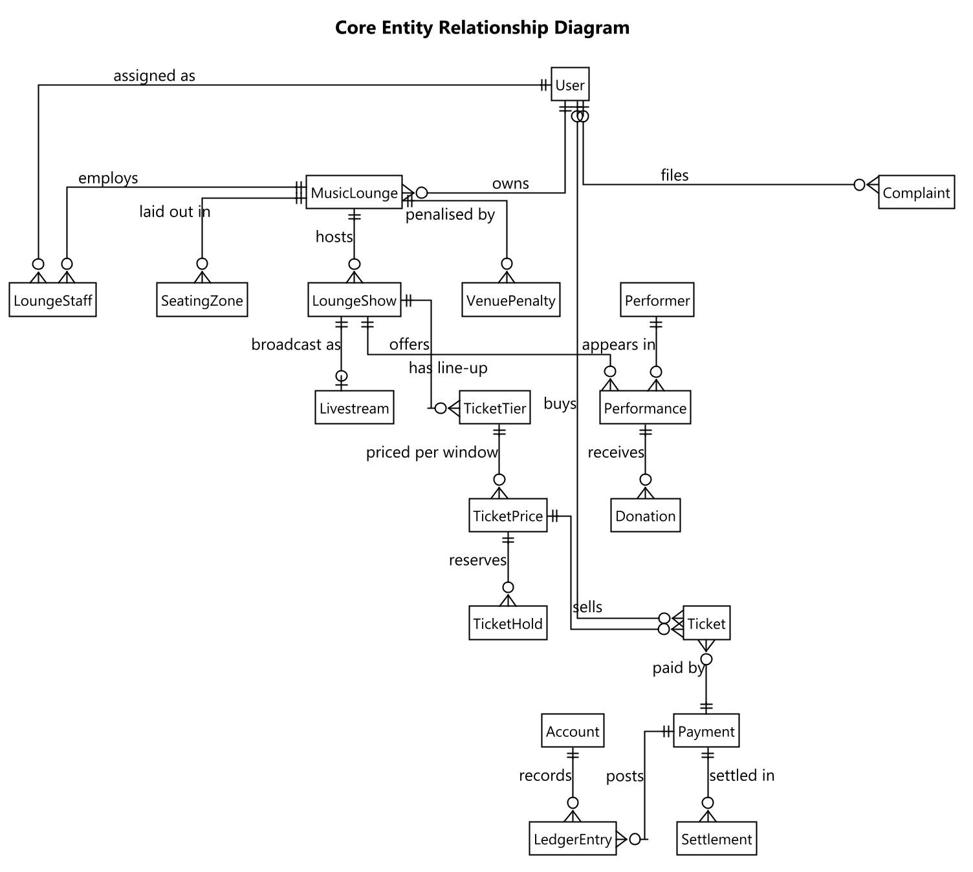
Figure 4 — Core entity relationship diagram (crow's-foot notation)
View the full ERD here: The complete ERD

3.2 Detailed Function Design
Documenting all 75 screens at full depth would not add proportional value here, so the features below were chosen to cover the value chain end to end — account, venue, show, ticket, livestream and donation, payment, moderation, complaint. Each gives the trigger, the actors and purpose, and the business rules that govern it. The remaining screens are specified by purpose, content and actions in §3.1.2 and by access in §3.1.3.

Register and verify an account
Trigger: The visitor submits the sign-up form on any surface.
Description: Creates an account in the chosen role — only Audience and Owner may self-register — and enqueues a one-time code by email. The account cannot sign in until the code is confirmed.
Business rules and validation:
• The password is hashed and never stored or logged in clear text.
• A duplicate email address is rejected at registration rather than silently merged.
• A wrong or expired code reports a specific error; a correct code activates the account.
• Resending the code is rate-limited so the address cannot be used to flood a target inbox.

Sign in
Trigger: The user submits email and password, or completes Google sign-in.
Description: Validates the credentials and then the account state in order — email verified, not locked, active, not erased — before issuing a session token carrying the role and, for Staff, the venue they are assigned to.
Business rules and validation:
• A wrong email and a wrong password return the same generic message, so the response cannot be used to discover which addresses are registered.
• Repeated failures increment a counter and, past a configured threshold, lock the account for a cool-down window.
• A Staff account whose assignment was deactivated still signs in but carries no venue, so every venue-scoped action then fails authorisation.

Register a venue and have it approved
Trigger: The Owner submits the venue form; an Admin later opens the approval queue.
Description: Creates the venue in a pending state. The Owner may edit it freely, but it is not publicly listed and no show at it may be published until an Admin approves it.
Business rules and validation:
• A business licence document must be uploaded before the venue can be reviewed.
• Approval is the single gate that unblocks public listing and show publication.
• A rejected venue has no resubmit path by design: the Owner creates a new record, so the rejection stays attached to an immutable one.

Create and submit a show for review
Trigger: The Owner completes the show form and chooses Submit for Review.
Description: Validates that the venue is approved and that at least one ticket tier and the legal permit reference exist, then moves the show from draft into the moderation queue.
Business rules and validation:
• An Owner without an active subscription is blocked at submission with an explanatory message rather than a late failure.
• Total tier capacity may not exceed the subscription plan's per-show ticket limit.
• The performance permit reference is required before submission.

Hold and pay for a ticket
Trigger: The Audience member selects a tier and quantity on Select Tickets.
Description: Creates a hold against a specific pricing window that expires after a configured window (15 minutes by default), decrementing available capacity for its duration, then redirects to the payment gateway.
Business rules and validation:
• Capacity is decremented when the hold is taken, not when payment completes, so a seat cannot be sold twice during the payment window.
• An expired unpaid hold is released automatically by a background job; no user action is needed.
• The gateway's server-to-server notification is the authoritative confirmation, so a ticket still confirms if the customer closes the browser.

Check in a ticket at the door
Trigger: Staff scan the ticket's code in the check-in scanner.
Description: Resolves the code to a ticket, evaluates eligibility, and shows a preview before Staff explicitly confirm, so a mis-scan does not consume the ticket.
Business rules and validation:
• A ticket is valid for the whole evening rather than a fixed time window, so there is no too-early or too-late rejection.
• Each refusal reason is reported distinctly: already used, wrong show, online-only ticket at a physical door, or frozen mid-transfer.
• There is no offline fallback — a dropped connection fails visibly rather than appearing to succeed.

Watch a gated livestream
Trigger: The Audience member opens the viewing room for a show that is running.
Description: Evaluates the caller before the stream is served: a confirmed ticket for this show, within the concurrent-device limit; or an operator of the venue; or an Admin.
Business rules and validation:
• A refused connection states which condition failed rather than showing a blank player.
• A transient network drop retries quietly and must not be presented as an access refusal.
• The viewer count is a manual-refresh figure, not a live counter.

Donate to a performer
Trigger: The Audience member opens Donate on a performer in the current line-up.
Description: Only performers whose slot accepts donations are offered. On payment confirmation the platform commission and tax are deducted and posted to the ledger, and the performer's share of the original gross is frozen onto the donation so a later configuration change cannot alter what was promised.
Business rules and validation:
• The gross splits four ways at confirmation: platform commission, tax, the performer's share, and the remainder retained by the venue for handling the payout.
• Status then advances from awaiting owner acknowledgement, to acknowledged, to performer paid — a multi-day pipeline the interface must represent honestly.
• Anonymity, amount visibility and message publication are three independent choices captured at donation time.
• The public transparency feed shows only acknowledged and paid donations, since an unacknowledged one can still be cancelled or refunded.

Process a payment and post the ledger
Trigger: The gateway calls back after a payment attempt, and again on retry.
Description: Verifies the callback signature and the amount before doing anything, then confirms the payment and writes a balanced double-entry journal split into gross, gateway fee, platform fee, tax withheld and net.
Business rules and validation:
• The handler is idempotent: the gateway retries, and a repeated callback must not post a second journal.
• A callback whose amount does not match the expected total is refused rather than trusted.
• Every journal must balance — total debits equal total credits — and a scheduled job re-verifies this.

Moderate a show or livestream
Trigger: An Owner submits content for review; an Admin opens the moderation queue.
Description: An AI risk score and recommendation are produced as advice only; the Admin decides. Approval is what makes a show public, and what unlocks the broadcast control for a livestream.
Business rules and validation:
• The AI result never auto-approves or auto-rejects; a human decision is always required.
• The review deadline is 24 hours, with an internal warning raised before it is missed.
• If the AI service is unavailable the item still enters the queue with a neutral score rather than blocking submission.

File and resolve a complaint
Trigger: Anyone, including a guest, submits the complaint form; an Admin resolves it from the queue.
Description: A signed-in complainant is linked to their account; a guest instead supplies a contact phone number and receives a reference number, which is the only way they can retrieve the case later.
Business rules and validation:
• A guest's reference number is shown once at submission and must be presented prominently, because it cannot be recovered from an account.
• Resolving with a refund against a ticket creates a refund request that still requires its own approval.
• Taking down a show cancels it outright and refunds every confirmed ticket — the heaviest available outcome.
• A guest complainant is notified of the outcome by SMS, since there is no in-app channel to reach them.

4. Non-Functional Requirements

4.1 External Interfaces
The platform integrates the services below, plus the cloud services it is deployed onto (Report 4 §1.4). Each integration's failure behaviour is stated, because how a dependency fails matters as much as what it does.
System | Role | Notes
VNPay | Payment Gateway | The sole payment intermediary for tickets, donations and subscriptions. The platform never handles card data — the customer is redirected to VNPay and an independent server-to-server IPN callback is the authoritative confirmation.
Mux / Cloudflare Stream | Live Video | RTMP ingest for broadcasting and HLS playback for viewers, behind one provider factory so either can be selected per environment.
Firebase Cloud Messaging | Push Notification | Delivers push notifications to the two mobile applications; a persistently failing device token is pruned automatically.
Google OAuth | Identity | Social sign-in alternative to local email and password accounts.
Google Maps | Geolocation | Venue address display and map-based location picking during venue setup.
SpeedSMS | SMS Gateway (Vietnam) | OTP and notification SMS inside Vietnam; replaced an earlier provider that could not deliver reliably to Vietnamese numbers.
Gemini | AI Services | Moderation risk scoring, show-poster generation and recommendation feature scoring. Every call degrades gracefully to a neutral result rather than blocking the request.
OpenAI | AI Services (alternate) | Alternate poster-image provider behind the same interface as Gemini.

4.2 Quality Attributes

4.2.1 Usability
• Every conditional action is shown or hidden according to real eligibility rather than shown and then refused, so a user is never invited to do something that will fail.
• Destructive or financially consequential actions require a confirmation proportional to their blast radius, not a single generic prompt.
• Empty, loading and error states are visually distinct from one another on every screen — three different conditions, three different presentations.
• Supported browsers are the current and previous major versions of Chrome, Edge, Firefox and Safari; the mobile applications support Android 10 and iOS 15 upward.
• The Audience Website is responsive across phone, tablet and desktop widths; the Owner Dashboard and Admin Console are desktop-first and assume at least 1024px.
• All three web surfaces meet WCAG 2.2 Level AA: keyboard reachable and operable with a visible focus indicator, labelled fields with errors announced to assistive technology, and text contrast of at least 4.5:1.
• No status is conveyed by colour alone; every state carries a text label or icon so it survives a colour-blind reader and a black-and-white printout.

4.2.2 Reliability
• Content moderation is reviewed within 24 hours, with an internal warning raised before the deadline lapses.
• A penalty appeal is reviewed within 48 hours; an appeal left unreviewed is overturned automatically rather than left stuck.
• A donation not acknowledged by the owner within 24 hours is auto-confirmed on their behalf.
• An acknowledged donation not forwarded to the performer raises a notification at 7 days and a venue penalty at 14 days.
• Every threshold above is configuration-driven rather than compiled in, so tuning one is an operational change and not a release.
• Door check-in and counter sales have no offline fallback by explicit decision: a dropped connection fails visibly rather than appearing to succeed.

4.2.3 Performance
• Ticket holds and seating-zone capacity are the most concurrency-sensitive paths in the system: a venue's real occupancy limit must never be oversold under concurrent load.
• The load shape to design for is a ticket on-sale spike — many simultaneous hold requests against one tier the moment sales open — combined with a concurrent livestream audience and its chat traffic.
• API response time targets under normal load: 95th percentile under 500 ms for reads and under 1 second for writes.
• Frontend budget on a mid-range device over a 4G connection: largest contentful paint under 2.5 seconds, interaction to next paint under 200 ms, and an initial bundle under 250 KB compressed per surface.
• Long-running work never blocks a request: stitching, poster generation, moderation scoring and settlement all run as background functions, and the screen that triggered them shows an explicit processing state.

4.2.4 Security
• Authorisation is checked in three layers on every request that touches one venue's data: role from the token, then policy, then venue scoping.
• There is deliberately no interface to create or promote an administrator; every such account is provisioned directly and a scheduled function alerts if one appears outside the known set.
• Sign-in responses never reveal which of email or password was wrong, and password-reset requests never reveal whether an address is registered.
• Repeated failed sign-ins are throttled by counter and lockout, and a burst from one source is separately detected as a credential-stuffing signal.
• Identity documents and identifiers are served only through protected, non-guessable endpoints and are stored encrypted, never as a public URL.

4.2.5 Compliance
• Payment intermediation — Decree 52/2024: All payment flows go through the licensed intermediary VNPay; the platform never touches card data.
• Withholding tax — Decree 117/2025: Tax withheld on qualifying payments is tracked per transaction and posted to a dedicated tax ledger account.
• Content takedown & phone verification — Decree 147/2024: A 24-hour moderation SLA with an internal warning at ~20 hours, and a verified-phone field on the user record.
• Mandatory complaint channel — Decree 85/2021: The complaint entity and its guest-accessible filing and lookup path exist to satisfy this obligation.
• Personal data protection — Law 91/2025/QH15: AI consent defaults to off, personal data can be exported and erased on request, and erasure anonymises in place rather than hard-deleting, so legally-retained financial records survive.
• Performance licensing and music copyright — Decree 144/2020 · VCPMC: A performance-permit reference and, where applicable, a royalty reference are required before a show may be submitted for review.

4.2.6 Maintainability
• The backend follows a layered architecture with a strict inward dependency rule enforced at the project-reference level, so a violation fails the build rather than passing review.
• Every business-tunable number — deadlines, hold duration, commission and tax rates, settlement thresholds — lives in configuration rather than in code, so operational tuning does not require a release.
• All five client surfaces share one API, one design system and one generated API client, so a contract change surfaces as a compile error in every consumer rather than a runtime failure in one.
• Each tier is deployed from source by the same pipeline, with environment configuration and secrets supplied at deploy time, so the artefact tested in staging is the one promoted to production.

5. Requirement Appendix

5.1 Business Rules
ID | Rule Definition
BR-01 | A venue starts pending and cannot be publicly listed, nor publish any show, until an Admin approves it.
BR-02 | A seating zone's capacity is a real physical occupancy limit and must never be oversold, including under concurrent load.
BR-03 | A ticket is valid for the whole evening of its show rather than a fixed time window.
BR-04 | Walk-in sales may continue after a show has started.
BR-05 | A ticket hold reserves capacity for a configured window and is released automatically if unpaid.
BR-06 | Capacity is decremented when a hold is taken, not when payment completes.
BR-07 | The payment gateway's server-to-server notification is the authoritative confirmation of payment.
BR-08 | Every confirmed payment writes a balanced double-entry journal; total debits must equal total credits.
BR-09 | A donation's gross splits at confirmation into platform commission, tax, the performer's share of the original gross, and the remainder retained by the venue for handling the payout.
BR-10 | The performer's share rate is frozen onto the donation at confirmation, so a later configuration change cannot alter what an existing donation promised.
BR-11 | The public transparency feed shows only acknowledged and paid donations.
BR-12 | An owner must hold an active subscription to submit a show for review.
BR-13 | Total ticket capacity for a show may not exceed the subscription plan's per-show limit.
BR-14 | A performance permit reference is required before a show may be submitted.
BR-15 | Every show and livestream requires a human Admin decision before becoming public; an AI score is advice only.
BR-16 | Content moderation must be decided within 24 hours of submission.
BR-17 | A penalty appeal not reviewed within 48 hours is overturned automatically.
BR-18 | A donation not acknowledged within 24 hours is auto-confirmed on the owner's behalf.
BR-19 | A Staff account may be actively assigned to exactly one venue at a time.
BR-20 | A Staff session is scoped to that one venue for its whole duration.
BR-21 | There is no self-service path to create or promote an administrator account.
BR-22 | A rejected venue cannot be amended and resubmitted; a new record must be created.
BR-23 | Cancelling a show refunds every confirmed ticket for it.
BR-24 | Changing a show from in-person to online is one-way and refunds every confirmed in-person ticket.
BR-25 | A refund is never paid automatically; every refund request requires an Admin decision.
BR-26 | A payout bank account must be verified by an Admin before any settlement is released to it.
BR-27 | Settlement is released in two tranches on a configured schedule rather than in one payment.
BR-28 | A guest complaint is retrievable only by its reference number together with the contact phone number given.
BR-29 | Personal data erasure anonymises the account in place and never hard-deletes records the law requires to be retained.
BR-30 | Behaviour logging and personalised recommendations are off unless the user opts in.

5.2 Common Requirements
• Every list endpoint accepts paging parameters and clamps the page size to a maximum, so a client cannot request an unbounded result set.
• Every error response uses one shape across the whole API — a success flag, a human-readable message and an optional field-level error map — so clients need only one error path.
• Every message shown to a user is in Vietnamese and phrased in plain language, without internal identifiers or stack detail.
• Every monetary value is stored and calculated in a decimal type, never a floating-point one, and rounded consistently at the same point in every calculation.
• Every timestamp is stored with its offset and rendered in the venue's local time.
• Every uploaded file is served through an endpoint that checks authorisation, never as a directly guessable public URL.

5.3 Application Messages List
# | Code | Type | Context | Content
1 | MSG-01 | Inline, form | Wrong email or password at sign-in | Email hoặc mật khẩu không đúng. Vui lòng kiểm tra lại.
2 | MSG-02 | Inline banner | Password reset requested | Nếu email đã đăng ký, liên kết đặt lại mật khẩu sẽ được gửi tới hộp thư của bạn.
3 | MSG-03 | Inline, form | Verification code wrong or expired | Mã xác thực không đúng hoặc đã hết hạn. Vui lòng gửi lại mã.
4 | MSG-04 | Toast | Ticket hold started | Đã giữ vé cho bạn trong 15 phút. Vui lòng hoàn tất thanh toán.
5 | MSG-05 | Toast | Ticket hold expired | Đã hết thời gian giữ vé. Vui lòng chọn lại.
6 | MSG-06 | Full screen | Payment succeeded | Thanh toán thành công. Vé của bạn đã sẵn sàng.
7 | MSG-07 | Full screen | Payment failed | Thanh toán không thành công. Chưa có khoản tiền nào bị trừ.
8 | MSG-08 | Inline banner | Show cannot be submitted | Chưa thể gửi duyệt: cần venue đã được duyệt, gói dịch vụ còn hiệu lực, ít nhất một hạng vé và khai báo giấy phép.
9 | MSG-09 | Scanner result | Check-in accepted | Vé hợp lệ. Mời khách vào.
10 | MSG-10 | Scanner result | Check-in refused | Vé không hợp lệ: {lý do cụ thể}.
11 | MSG-11 | Player overlay | Livestream access refused | Bạn cần vé hợp lệ cho buổi diễn này để xem, hoặc đã vượt số thiết bị cho phép.
12 | MSG-12 | Modal | Complaint submitted by a guest | Đã ghi nhận khiếu nại. Mã tra cứu của bạn là {mã}. Vui lòng lưu lại — đây là cách duy nhất để tra cứu.
13 | MSG-13 | Confirmation | Erase my data | Thao tác này không thể hoàn tác. Tài khoản sẽ bị ẩn danh vĩnh viễn và bạn sẽ bị đăng xuất khỏi mọi thiết bị.

